- Copy KL520-W25Q256JV-scpu.FLM and KL520-W25Q256JV-ncpu.FLM to C:\Keil_v5\ARM\Flash
- Settings for NCPU projects
2.1 set ncpu project as active project, and then open Option for Target\Utilities\Settings
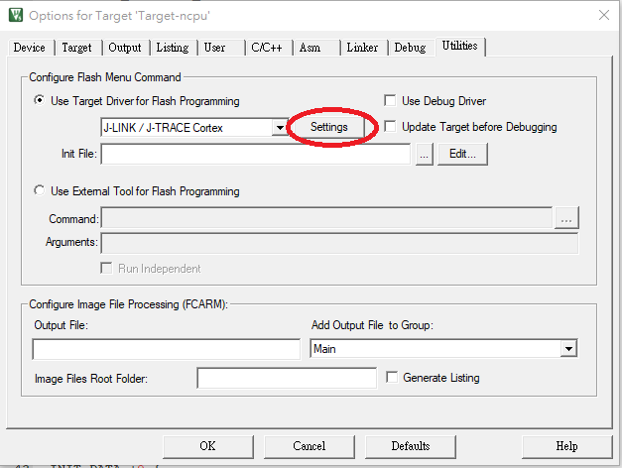
2.2 Set Flash download settings as following picture, and add ‘C:\Keil_v5\ARM\Flash\KL-520-W25Q256JV-ncpu.FLM’ to be the Programming Algorithm.
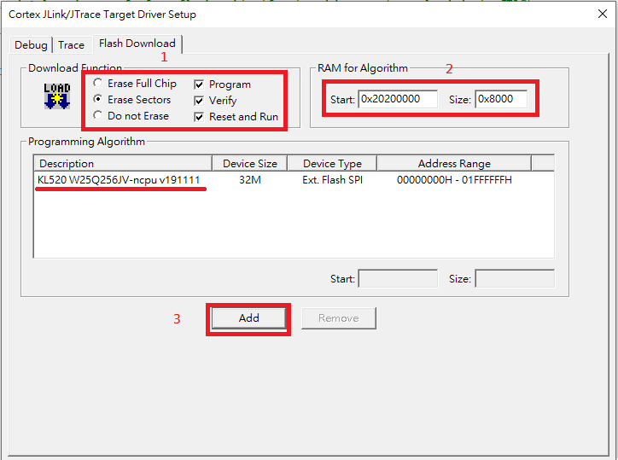
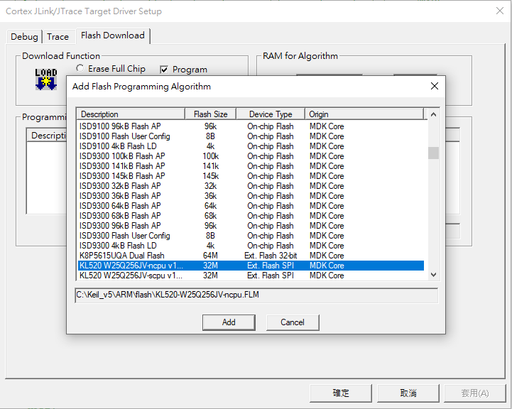
- Settings for SCPU projects
3.1 set scpu project as active project, open Option for Target\Utilities\Settings, then set Flash download settings as following picture, and add ‘C:\Keil_v5\ARM\Flash\KL520-W25Q256JV-scpu.FLM’ to be the Programming Algorithm
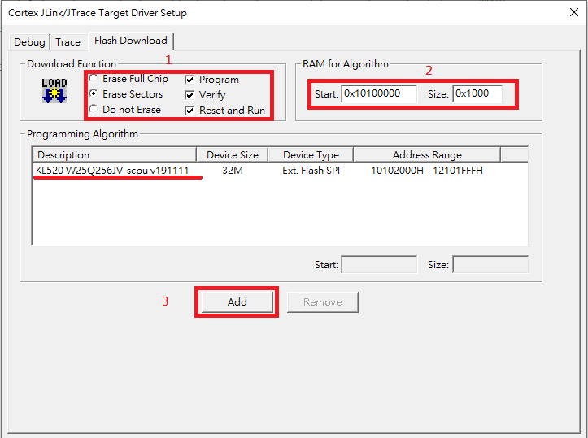
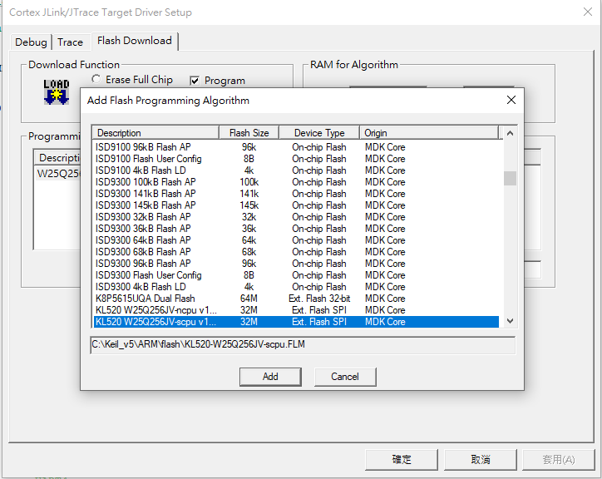
- Once you’ve done modification and compilation, just press ‘load’ icon in Flash/Download, you can update your code by JLink immediately.
